It is FREE to participate!

Sponsored by Dr. Elsey’s (Thank You!)
$125 for First Place
$100 2nd
$75 3rd
$50 4th
$25 5th

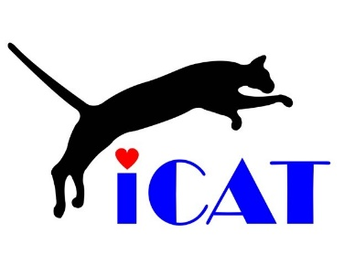
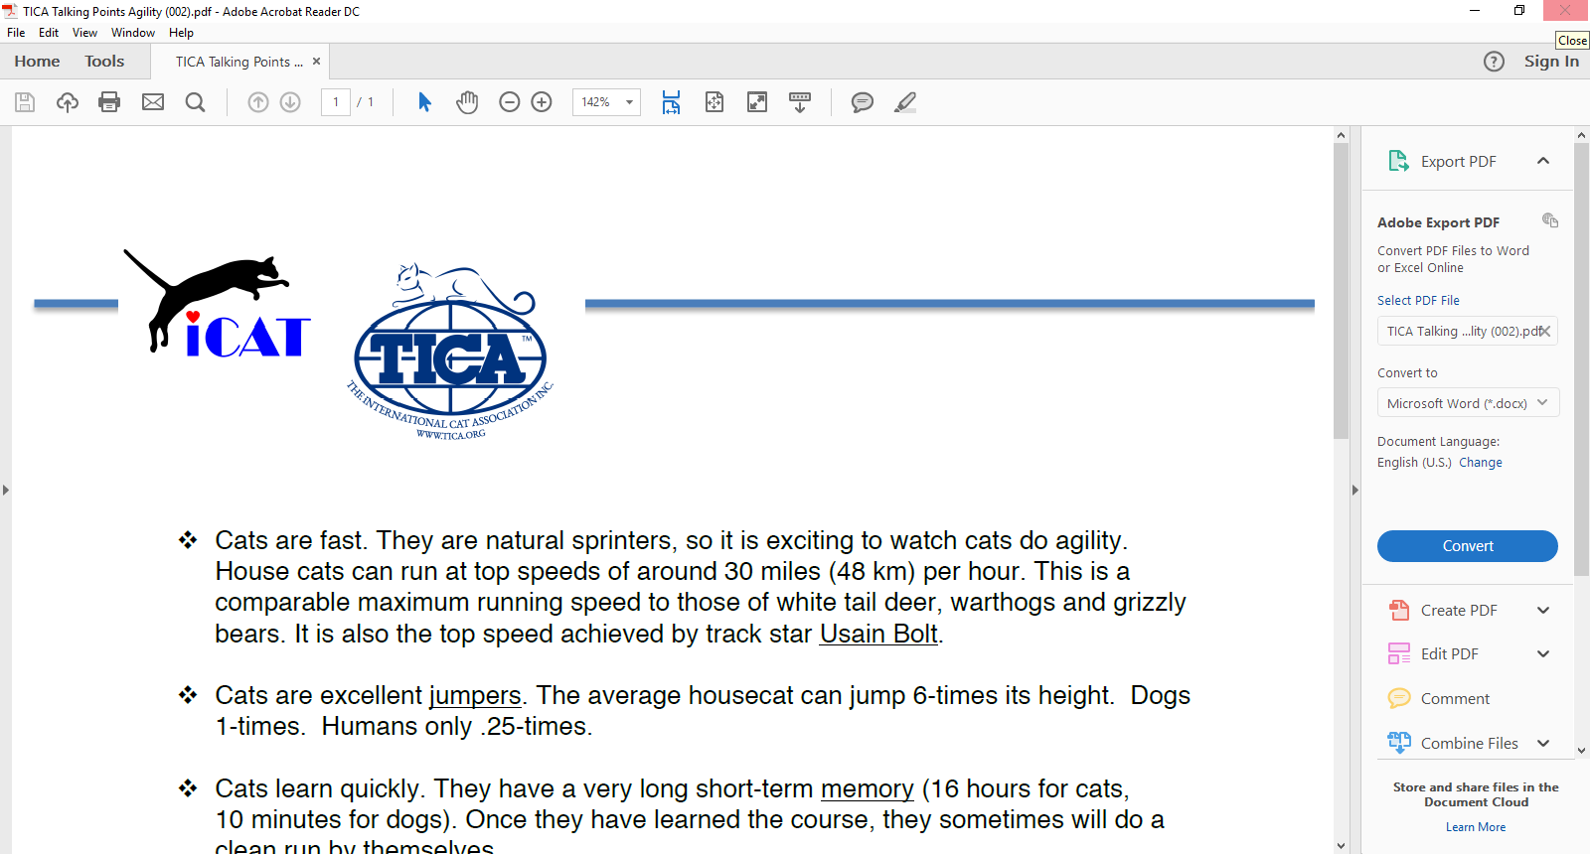

®

International Cat Agility Tournaments
www.catagility.com

Welcome to the ICAT cat agility ring!

Once in the ring, please wait until your cat has completed investigating all of the obstacles, and its tail goes up, which indicates it feels safe, and is ready to play.
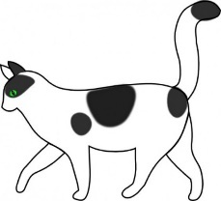
A cat is saying, “I feel happy and safe”
when it walks with its tail up
There is no pressure to learn the obstacles and do timed runs. This is a positive time for you and your cat. If you want to, you can simply sit on the floor and play with your cat, like in a kindergarten.

Cat agility is not the same as dog agility. It is better! It is more interesting because of cats' abilities:
​
- Cats are fast. They are natural sprinters, so it is exciting to watch an experienced cat do agility. House cats can run at top speeds of around 30 miles (48 km) per hour. This is a comparable maximum running speed to those of white tail deer, warthogs and grizzly bears. It is also the top speed achieved by track star Usain Bolt. (www.catagility.com/usain-bolt-versus-cheetah)
​
- Cats are excellent jumpers. The average domestic cat can jump 6-times its height. Dogs can jump about 1-times their height. Average humans only about ¼-times their height.
​
- Cats learn quickly. They have a very long short-term learning memory (10 minutes for dogs, 16 hours for cats). Once cats have learned the course, they sometimes do a clean run alone. ​
​
- Cats have excellent short-distance visual focus and accuracy (so do foxes), because they are low to the ground, and capture prey by pouncing. ​​

- Domestic cats have a “colony” social structure, which means they have friends and grooming buddies. As their friends, cats learn from us how we want them to negotiate each obstacle. Then cats make their own decision to do agility, because they want to.

Cat agility is fun for you AND your cat!
Please remove your shoes before entering the ring, so it will be easier to clean and disinfect between cats.

Is Your Cat Ready for Agility?

Self Confidence
Can your cat handle new situations calmly, and enjoy investigating new things? Are new people interesting to your cat? Your agility cat should be interested in agility, love running, jumping, and climbing, and generally be interactive with the people and objects in its environment. Shy cats may enjoy playing at home, but may be limited in their ability to have fun and enjoy agility at big, noisy shows. When you cat's tail is up, in what we call the "happy cat" position, it is ready to learn or do an agility course.

Athletic Ability
In order to negotiate the obstacles on an agility course, a cat needs good overall health, stamina, conditioned lean weight, and an energetic outlook on life. Have your cat checked by a veterinarian and make sure it is physically up to agility, free from any malady or structure flaw that will interfere with its ability to run or negotiate obstacles. You and your cat can have fun if you're both healthy and interested in agility, even if reaching super stardom isn't attainable because of your cat's age, overweight, or conformation.

Training
Once you've determined your cat has the right personality and physical condition for agility, here are some ways of training:
- Lure with a toy (keep far enough ahead with the toy)
- Double-tap with a toy ahead of the obstacle (a favorite method)
When training, you can lift your cat over the obstacle, so they know what you want. Be patient, and find the joy in working together and building a closer relationship with your cat. The cats having the most fun are going to be the ones who do the best.

Motivation
The primary motivator for dogs is food, but for cats, it is play. Play with your cats, run them around your house, and if they do something well, reward them with praise, or a very small tidbit of food, but mostly praise and love. Cats running an agility course also need to be focused, paying attention to their handler, alert and responsive. Praise and love at home will keep up the focus level in the agility ring. Lure with a toy, or double-tap with a stick to indicate where to go, or use your hand to guide them. Clicker-training is effective but cats learn complex things quickly.

"Cat Years"
ICAT agility competitions are for cats 4 months of age or older, their pre-teen years. Cats will age 10 years equivalent in the first six months of their life. Then they will age 5 more years in the next six months, bringing the total number of "cat years" to 15 in their first year of life. After this initial age spurt, you can expect your cat to age four years for every year of its life. So if your cat is three years old in "people years," it is 23 years old in "cat years." Old age can affect the mental sharpness of cats, the same as with people.

Play with Your Cat Every Day Focusing on the Beauty from Within
International Cat Agility Tournaments
www.catagility.com
ICAT cat agility courses include these 5 core components of PHYSICAL fitness: ​

- Agility (changing body position)
- Balance
- Speed (endurance)
- Power (burst)
- Reaction time

These 4 MENTAL dexterity exercises are employed in ICAT cat agility:​

- Concentration
- Trust
- Learning
- Surface texture variety is interesting and challenging
®
Copyright © 2017 by International Cat Agility Tournaments (ICAT)

